GitHub Eclipse IDE Plugin Setup Guide

File History:
S.No | Document Name | Version | Created By | Created Date | Modified By | Modified Date
1 | GitHub Eclipse Plugin Setup Guide-v1.0.doc | v1.0 | Nagarjuna Goud Tummala | 03/06/2016

Step#: Open the Eclipse IDE
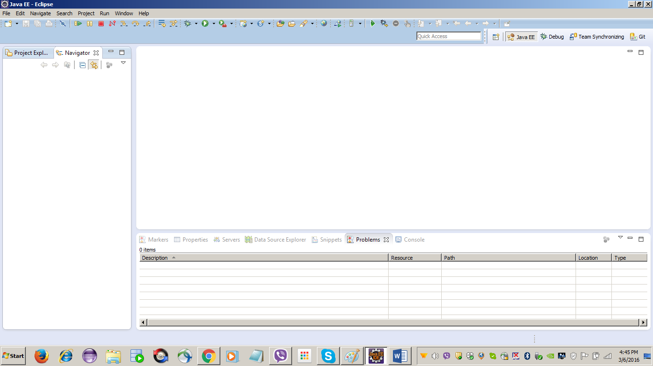

Step#: Select Install New Software.. menu item
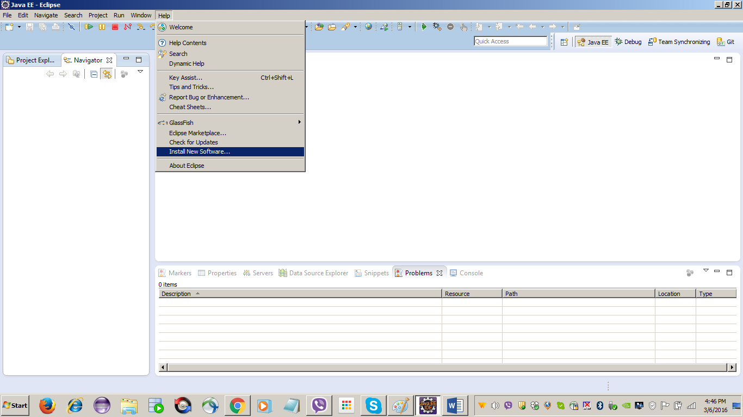

Step#: Click the Add button
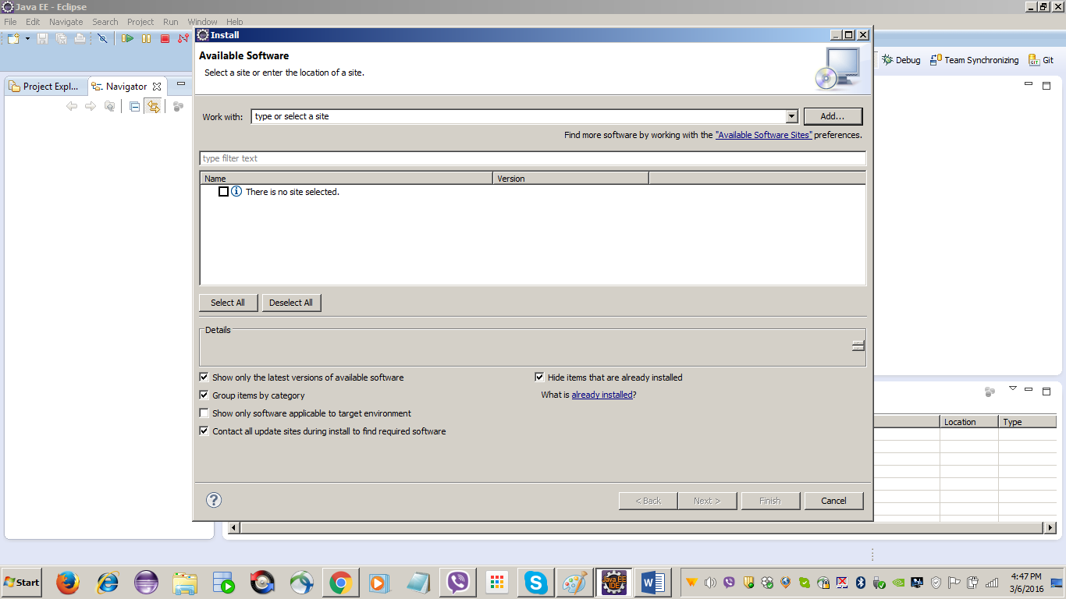

Step#: Add the below information and click on the OK button
Name: GitHub
Location: http://download.eclipse.org/egit/updates
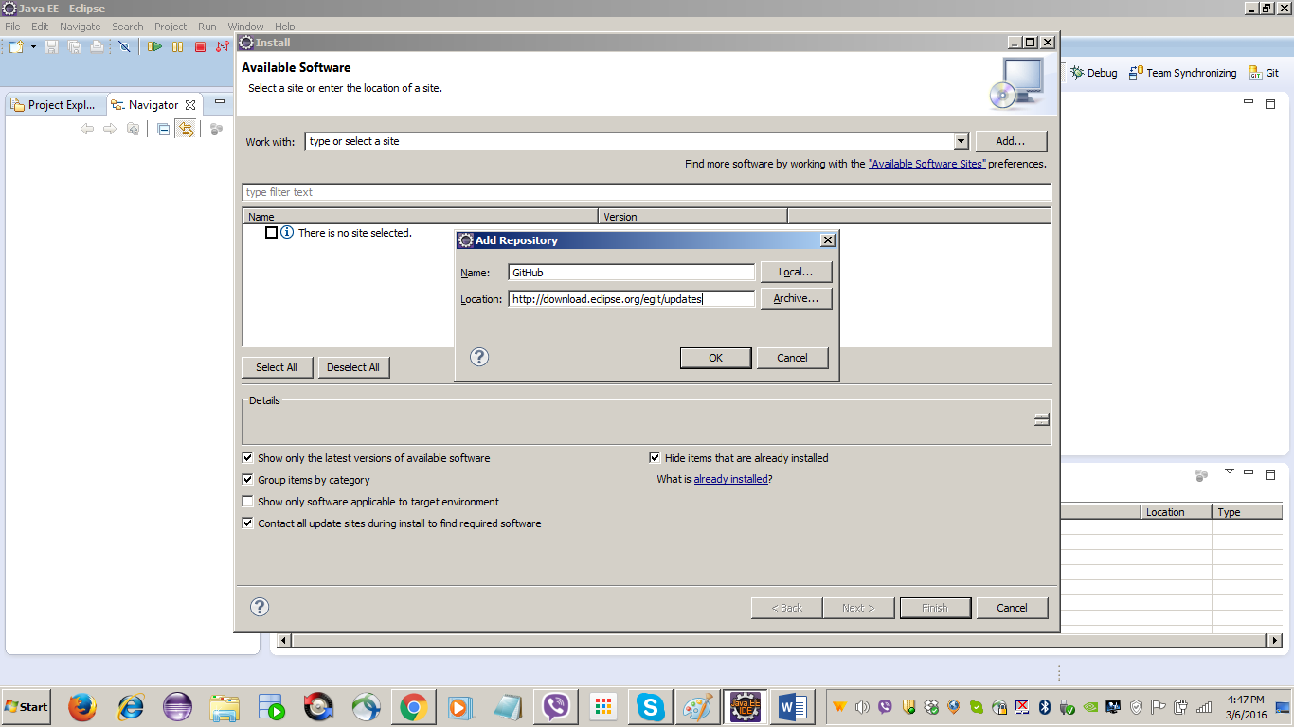

Step#: Click Select All button and click the Next button
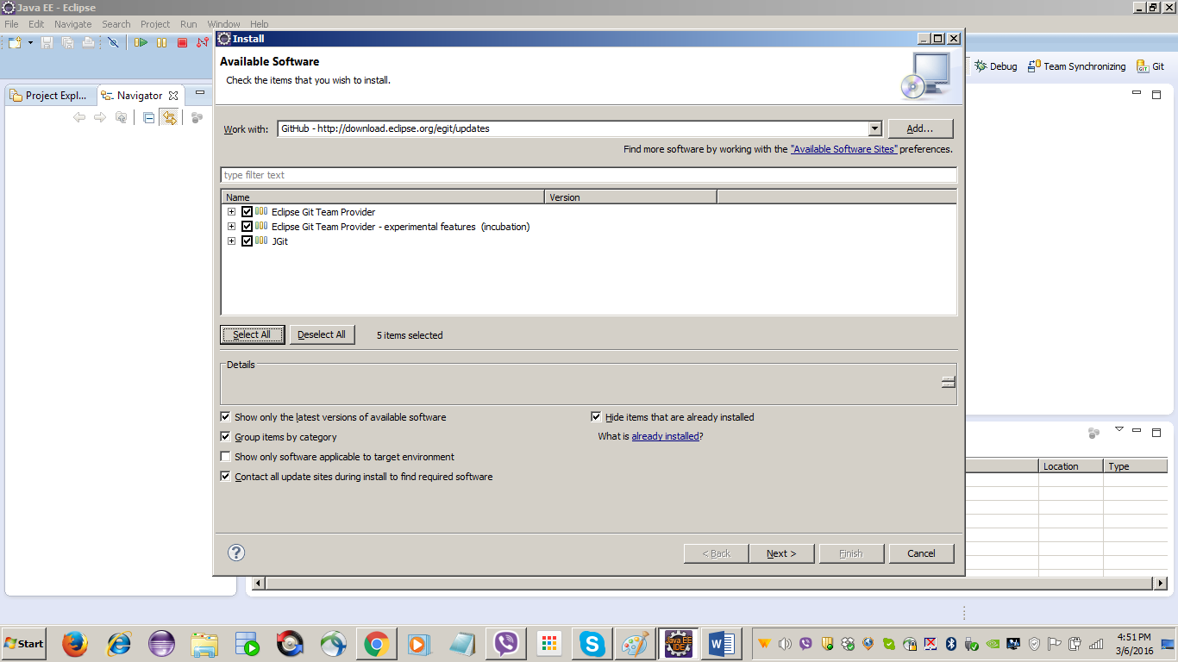

Step#: Click Next button
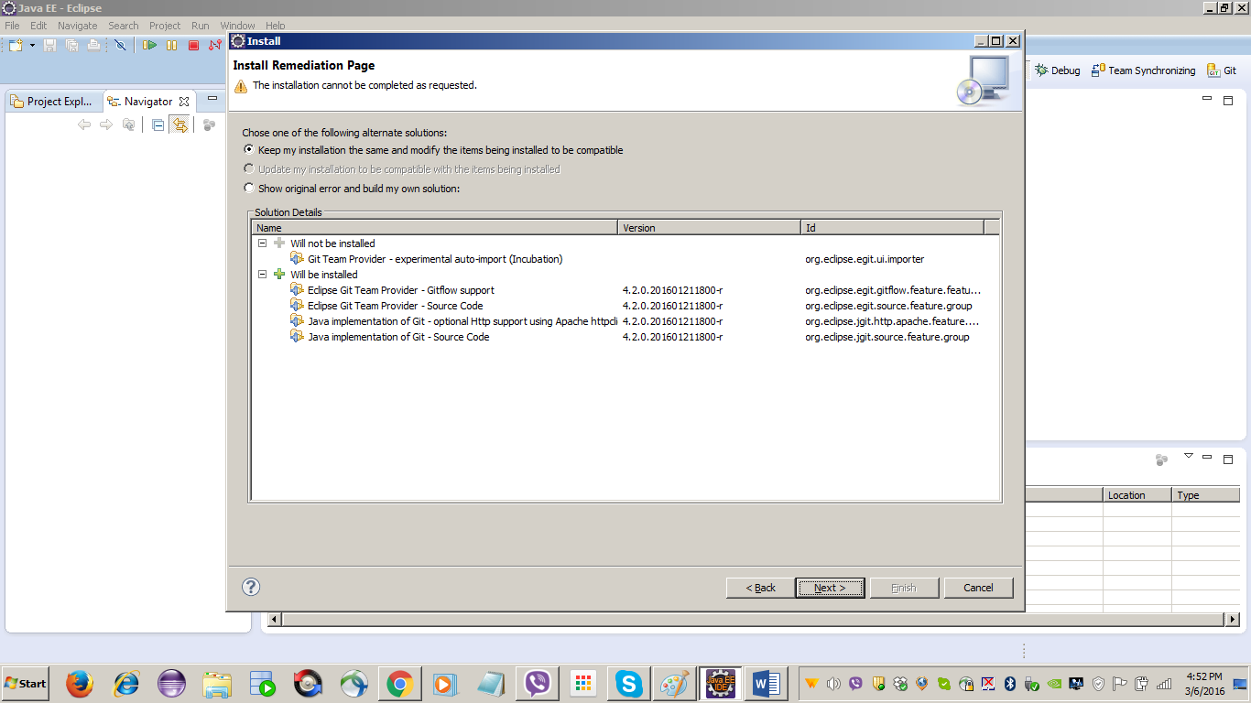

Step#: Click Next button
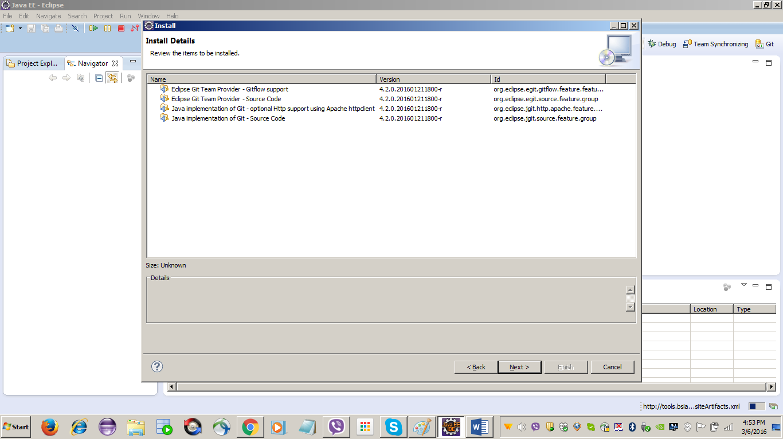

Step#: Select I accept the terms of the license agreement radio button and Click Finish button
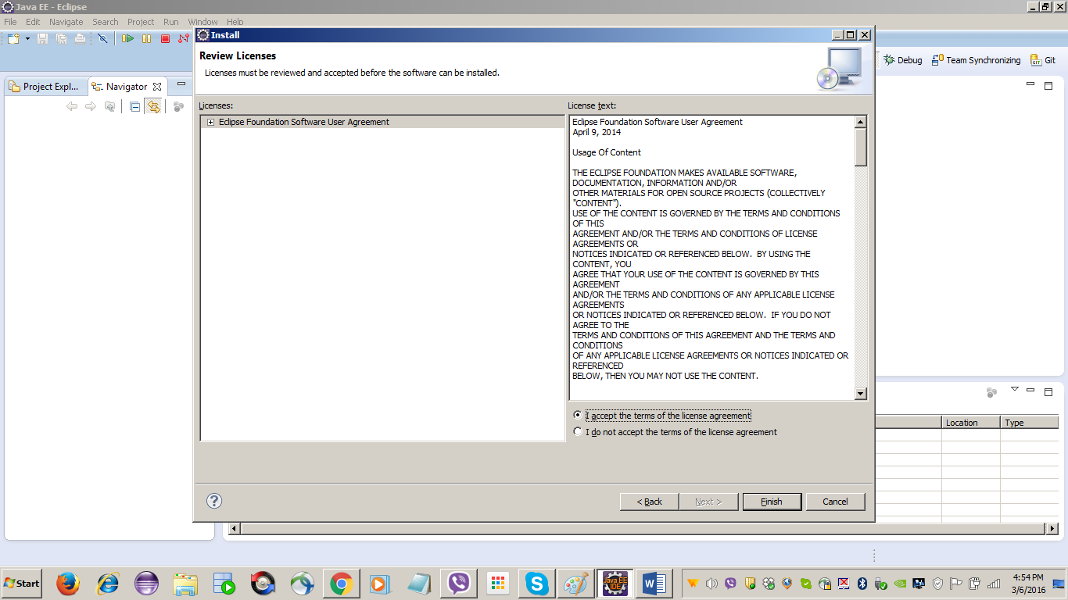

Step#: Click Yes button to restart the Eclipse IDE
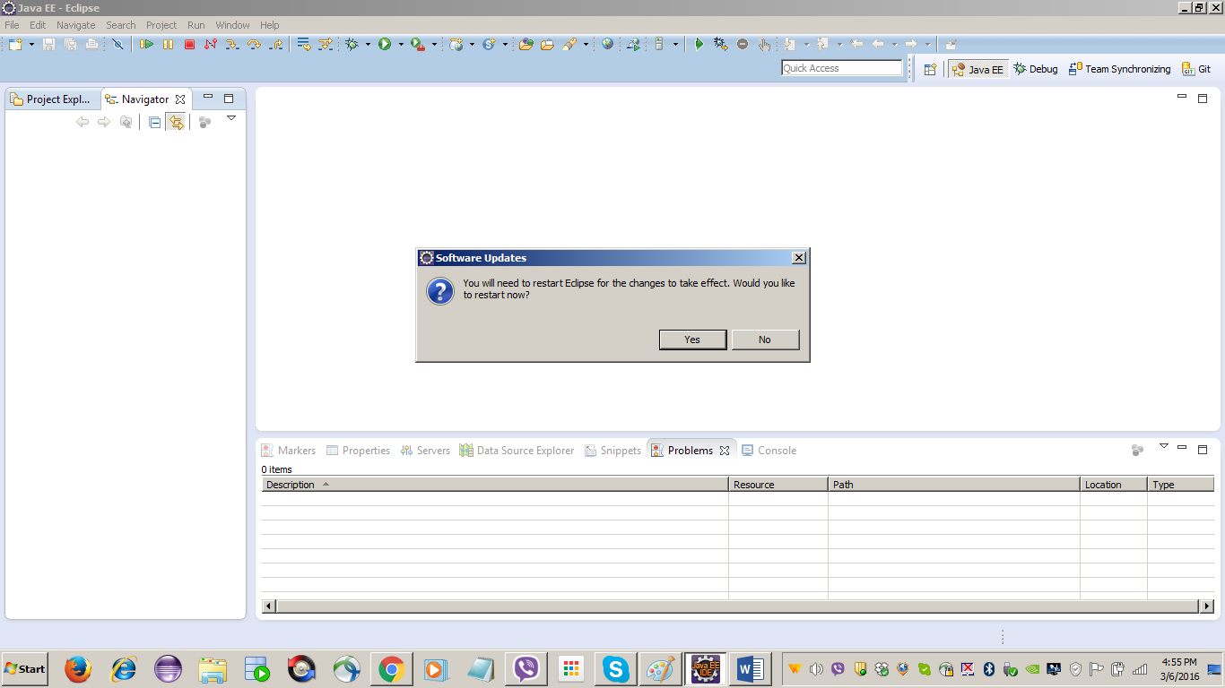

Happy Learning …!!

Thank You

